TBSS-LONGLEAF Manual ~

Tengfei Li @ UNC

Nov 24, 2018

1. Login on the department Longleaf cluster. For Windows users, using x-win32 or putty, and connect to the host “longleaf.unc.edu”; for Mac users, open a terminal to type the following command.

ssh username@longleaf.unc.edu

And then type you UNC usrname and password. Install software Winscp or sshClient for windows, or filezilla or cyberduck for Mac. These softwares are for **uploading/downloading** files from longleaf. Install Mango and Mricron software to open images or check the quality.

1. All DTI related images including FA, V1, L1, L2, L3, MD, MO with subject ID= SubID1, SubID2, SubID3,...SubIDN are collected at (suppose there are N subjects)

/PATH/TBSS/FA/SubID1_FA.nii.gz /PATH/TBSS/V1/SubID1_V1.nii.gz …

/PATH/TBSS/L1/SubID1_L1.nii.gz /PATH/TBSS/L2/SubID1_L2.nii.gz …

/PATH/TBSS/L3/SubID1_L3.nii.gz /PATH/TBSS/MD/SubID1_MD.nii.gz …

/PATH/TBSS/MO/SubID1_MO.nii.gz

/PATH/TBSS/FA/SubID2_FA.nii.gz /PATH/TBSS/V1/SubID2_V1.nii.gz

…

For example, if you will process all SubID start with “1”, you should first copy all files at /OtherPATH/TBSS/FA/ that start with “1” to /PATH/TBSS/FA/ using the command (also copy V1,L1,L2,L3… similarly)

cp -r /OtherPATH/TBSS/FA/1* /PATH/TBSS/FA/1*

cp -r /OtherPATH/TBSS/V1/1* /PATH/TBSS/V1/1*

cp -r /OtherPATH/TBSS/L1/1* /PATH/TBSS/L1/1*

…

pasted-image.tiffThe FA, V1 … image example opened by Mricron or Mango software for UKBiobank data:

pasted-image.tiffpasted-image.tiff

**Example: FA L1 (AD) MD**

pasted-image.tiff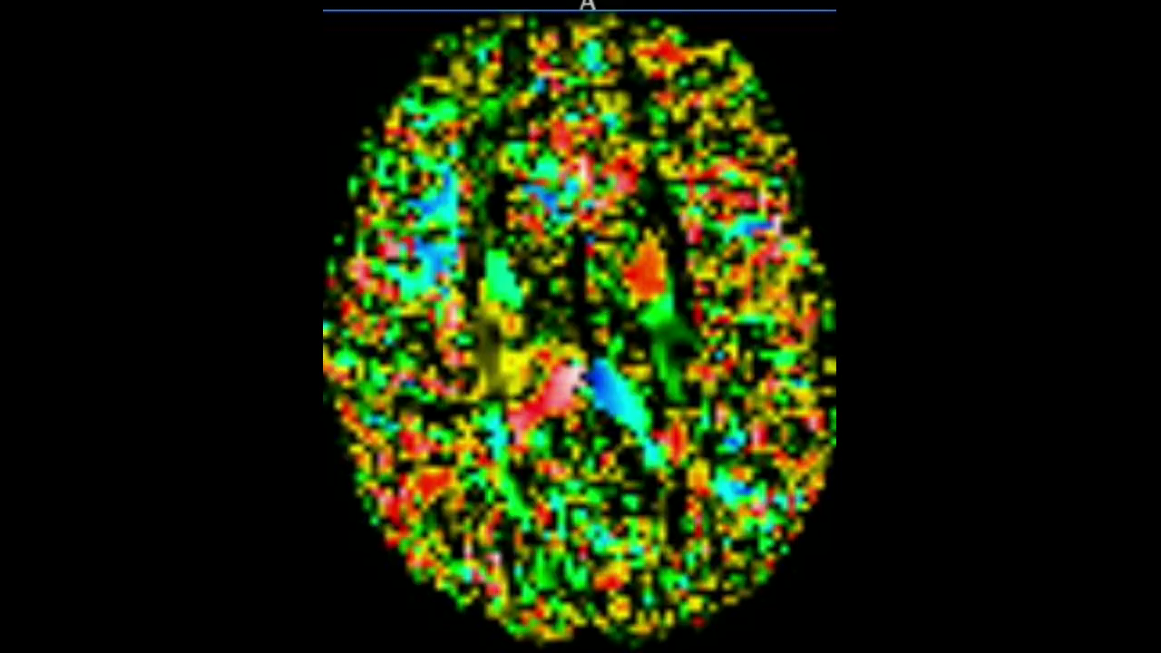pasted-image.tiff

**Example: S0 (B0) V1 MO**

Upload folders step1, step2, step3 to /PATH/ using uploading softwares. Uploading folders ENIGMA_targets, Enigma_ROI_1, enigmaDTI_QC to /PATH/TBSS/. Modify the string PATH in step1/Pre_QC_makefile.m, step1/Pre_QC_makeimage.m and step1/Pre_QC_html.m to your specific PATH. (Remember: double check to make sure you save your modification on server; for all the following script files, remember to change your path first before running it). Type the following command at the terminal to run the matlab file step1/Pre_QC_makefile.m.

cd /PATH/step1/

module load matlab

matlab -nojvm

Pre_QC_makefile

exit

This will create a new folder “TBSS/Pre_QC” at /PATH/ and generate the file TBSS/Pre_QC/Subject_Path_Info.txt which gives the path to each individual FA and V1 files.

pasted-image.tiff

3. Type the following command at the terminal to run the matlab file Pre_QC_image.m.

cd /PATH/step1/

module load matlab

matlab -nojvm

Pre_QC_image

exit

If it is done, open and check file

/PATH/code/FDT_bat1.pbs

which (roughly) reads like

“

#!/bin/bash

#SBATCH --ntasks=1

#SBATCH --time=23:59:59

#SBATCH --mem=8000

#SBATCH --wrap=TBSS_1

module load fsl

module load python/2.7.12

export FSLDIR=/nas/longleaf/apps/fsl/5.0.9/fsl/

source ${FSLDIR}/etc/fslconf/fsl.sh

export PATH=${FSLDIR}/bin:${PATH}

cd /pine/scr/t/e/tengfei/ukbiobank_tbss/code/

module load matlab

for ((i=1;i<=20;i++)); do

matlab -nosplash -nodesktop -r FDT_bat$i>>$i.out

done

”

Then execute the /PATH/code/FDT_batAll.sh file using the following commands to submitpasted-image.tiff all .pbs jobs for all subjects.

“

cd /PATH/code/

chmod 775 FDT_batAll.sh

./FDT_batAll.sh

”

This step will generate all FA quality-control images in the folder /PATH/TBSS/Pre_QC/QC_FA_V1. Please make sure all jobs are completed using the Linux command

“squeue -u your-username”. You can also use

squeue –u usrname | grep R –c

to calculate how many jobs are still running, and

squeue –u usrname | grep Q –c

to calculate how many jobs are still pending. Then check that if the number of .png files inside /PATH/TBSS/Pre_QC/QC_FA_V1 is equal to the total number of subjects.

Next, type the following command at the terminal to run the matlab file Pre_QC_html.m.

cd /PATH/step1/

module load matlab

matlab -nojvm

Pre_QC_html

exit

After Pre_QC_html.m is completed, an .html file

/PATH/TBSS/Pre_QC/QC_FA_V1/index.html

will be generated. Download the folder /PATH/TBSS/Pre_QC/QC_FA_V1/ to your own desktop from longleaf, and open QC_FA_V1/index.html to check thepasted-image.tiff image quality.pasted-image.tiff

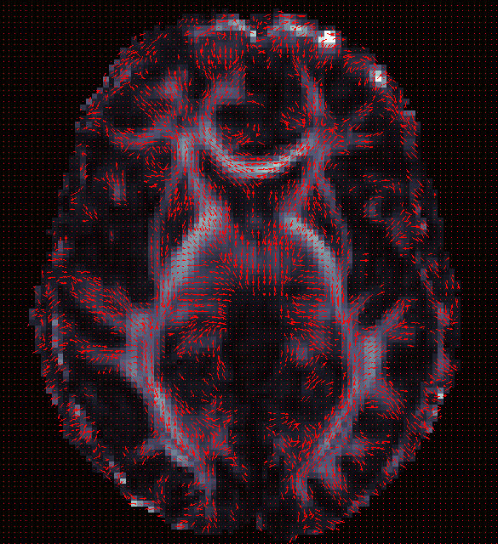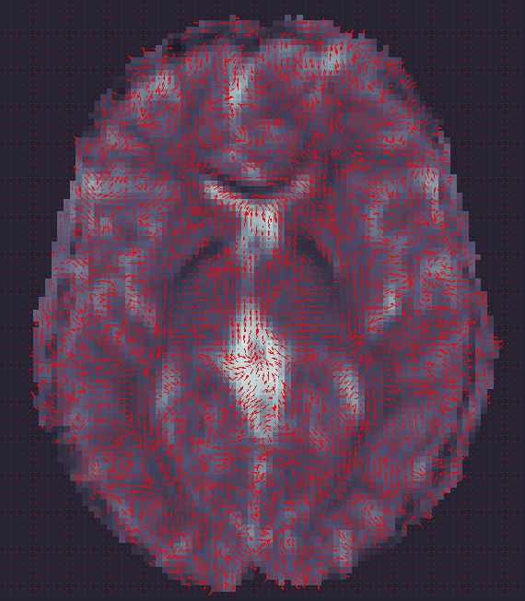

Check the quality of each image in the .html file and make a record of all bad subjects you think in a .txt file.

**4. Preprocessing** **of FA.**

Good bad

**Procedure:**

Type the following command at the terminal to run the matlab file

/Path/step2/FA_TBSS_11.m

“

cd /PATH/step2/

module load matlab

matlab -nojvm

FA_TBSS_11

exit

”

And a new file /Path/code/tbss_1.pbs will be generated which reads like:

“

#!/bin/bash

#SBATCH --ntasks=1

#SBATCH --time=23:59:59

#SBATCH --mem=8000

#SBATCH --wrap=TBSS

module load fsl

module load python/2.7.12

export FSLDIR=/nas/longleaf/apps/fsl/5.0.9/fsl/

source ${FSLDIR}/etc/fslconf/fsl.sh

export PATH=${FSLDIR}/bin:${PATH}

mkdir /pine/scr/t/e/tengfei/ukbiobank_tbss/TBSS/FAtbss

cp /pine/scr/t/e/tengfei/ukbiobank_tbss/TBSS/FA/*_FA.nii.gz /pine/scr/t/e/tengfei/ukbiobank_tbss/TBSS/FAtbss/

cd /pine/scr/t/e/tengfei/ukbiobank_tbss/TBSS/FAtbss

tbss_1_preproc *.nii.gz

mkdir /pine/scr/t/e/tengfei/ukbiobank_tbss/TBSS/FAtbss/FA2ENIGMAtemplate

cp /pine/scr/t/e/tengfei/ukbiobank_tbss/TBSS/FAtbss/FA/*_FA_FA.nii.gz /pine/scr/t/e/tengfei/ukbiobank_tbss/TBSS/FAtbss/FA2ENIGMAtemplate

“

Submit /Path/code/tbss_1.pbs by using

cd /Path/code/

sbatch tbss_1.pbs

And make sure it runs sucessfully. When it is completed, new folders

/PATH/TBSS/FAtbss;/PATH/TBSS/FAtbss/FA;/PATH/TBSS/FAtbss/FA2ENIGMAtemplate

will be generated; files

/PATH/TBSS/FAtbss/FA/SubID/SubID_FA_FA.nii.gz

/PATH/TBSS/FAtbss/FA/SubID/SubID_FA_FA_mask.nii.gz

will be generated. SubID_FA_FA.nii.gz is the preprocessed FA.

Original FA Preprocessed FA



**5.** **Run Linear registration.**

Type the following command at the terminal to run the matlab file

/Path/step2/FA_TBSS_12.m

“

cd /PATH/step2/

module load matlab

matlab -nojvm

FA_TBSS_12

exit

”

And new files such as /Path/code/tbss_1_1.pbs will be generated which reads like:

“

#!/bin/bash

#SBATCH --ntasks=1

#SBATCH --time=01:59:59

#SBATCH --mem=8000

#SBATCH --wrap=TBSS_1

module load fsl

module load python/2.7.12

export FSLDIR=/nas/longleaf/apps/fsl/5.0.9/fsl/

source ${FSLDIR}/etc/fslconf/fsl.sh

export PATH=${FSLDIR}/bin:${PATH}

cd /pine/scr/t/e/tengfei/ukbiobank_tbss/TBSS/FAtbss

flirt -in ./FA2ENIGMAtemplate/6002122_FA_FA.nii.gz -ref /pine/scr/t/e/tengfei/ukbiobank_tbss/TBSS/ENIGMA_targets/ENIGMA_DTI_FA.nii.gz -out ./FA2ENIGMAtemplate/6002122_FA_to_target.nii.gz -omat ./FA2ENIGMAtemplate/6002122_FA_to_target.mat -dof 9

…

”

Then execute the /PATH/code/tbss_1T.sh file using the following commands to submit all .pbs jobs for all subjects.

“

cd /PATH/code/

chmod 775 tbss_1T.sh

./tbss_1T.sh

”

This step will linearly register all preprocessed FA images

/PATH/TBSS/FAtbss/FA/SubID/SubID_FA_FA.nii.gz

to FA template /PATH/TBSS/ENIGMA_targets/ENIGMA_DTI_FA.nii.gz. Please make sure all jobs are completed using the Linux command “squeue -u your-username”. Then repeat this step by running the matlab file FA_TBSS_12.m again, until /Path/code/tbss_1T.sh reads like:

“

#!/bin/bash

”

Then all subjects have been successfully registered to the ENIGMA_DTI_FA.nii.gz.

The output (registered FA images and linear transformation matrix) are

/PATH/TBSS/FAtbss/FA2ENIGMAtemplate/SubID_FA_to_target.nii.gz

/PATH/TBSS/FAtbss/FA2ENIGMAtemplate/SubID_FA_to_target.matpasted-image.tiffpasted-image.tiff

Template: ENIGMA_DTI_FA.nii.gz SubID_FA_to_target.nii.gz SubID_FA_to_target.nii.gz

**6. Quality control of the linear registration**

Type the following command at the terminal to run the matlab file

/Path/step2/FA_TBSS_13.m

“

cd /PATH/step2/

module load matlab

matlab -nojvm

FA_TBSS_13

exit

”

And a new file /Path/code/tbss_13.sh will be generated which reads like:

“

#!/bin/bash

module load fsl

module load python/2.7.12

export FSLDIR=/nas/longleaf/apps/fsl/5.0.9/fsl/

source ${FSLDIR}/etc/fslconf/fsl.sh

export PATH=${FSLDIR}/bin:${PATH}

mkdir /pine/scr/t/e/tengfei/ukbiobank_tbss/TBSS/FAtbss/QC_Reg

cd /pine/scr/t/e/tengfei/ukbiobank_tbss/TBSS/FAtbss

cp ./FA2ENIGMAtemplate/*_FA_to_target.nii.gz ./QC_Reg

cd /pine/scr/t/e/tengfei/ukbiobank_tbss/TBSS/FAtbss/QC_Reg/

$FSLDIR/bin/slicesdir `$FSLDIR/bin/imglob *_FA_to_target.*` > grot 2>&1

cat grot | tail -n 2

/bin/rm grot

”

Then execute the /PATH/code/tbss_13.sh using:

“cd /PATH/code/

sh tbss_13.sh”

The html folder for quality control will be generated at:

/PATH/TBSS/FAtbss/QC_Reg/slicesdir/index.html

Download the folder /PATH/TBSS/FAtbss/QC_Reg/slicesdir/ to your own desktop and open index.html to roughly check the registered image quality.pasted-image.tiff

**7. Nonlinear registration of FA image**

Type the following command at the terminal to run the matlab file

/Path/step2/FA_TBSS_2_and_3.m

“

cd /PATH/step2/

module load matlab

matlab -nojvm

FA_TBSS_2_and_3

exit

”

And new files such as /Path/code/tbss_23_1.pbs will be generated which reads like:

“

#!/bin/bash

#SBATCH --ntasks=1

#SBATCH --time=01:59:59

#SBATCH --mem=8000

#SBATCH --wrap=TBSS_1

module load fsl

module load python/2.7.12

export FSLDIR=/nas/longleaf/apps/fsl/5.0.9/fsl/

source ${FSLDIR}/etc/fslconf/fsl.sh

export PATH=${FSLDIR}/bin:${PATH}

cd /pine/scr/t/e/tengfei/ukbiobank_tbss/TBSS/FAtbss

mkdir -p ./FA_individ/6002122/stats/

mkdir -p ./FA_individ/6002122/FA/

cp ./FA/6002122_*.nii.gz ./FA_individ/6002122/FA/

cd /pine/scr/t/e/tengfei/ukbiobank_tbss/TBSS/FAtbss/FA_individ/6002122

fsl_reg ./FA/6002122_FA_FA.nii.gz /pine/scr/t/e/tengfei/ukbiobank_tbss//TBSS/ENIGMA_targets/ENIGMA_DTI_FA.nii.gz ./FA/6002122_FA_FA_to_target -FA

cp /pine/scr/t/e/tengfei/ukbiobank_tbss/TBSS/ENIGMA_targets/ENIGMA_DTI_FA.nii.gz ./FA/target.nii.gz

tbss_3_postreg -S

rm ./FA/6002122_FA_to_target.nii.gz

${FSLDIR}/bin/fslmaths ./FA/6002122*_FA_to_target.nii.gz -mas /pine/scr/t/e/tengfei/ukbiobank_tbss/TBSS/ENIGMA_targets/ENIGMA_DTI_FA_mask.nii.gz ./FA/6002122_masked_FA.nii.gz

cp ./FA/6002122_masked_FA.nii.gz /pine/scr/t/e/tengfei/ukbiobank_tbss/TBSS/FAtbss/FA/

${FSLDIR}/bin/tbss_skeleton -i ./FA/6002122_masked_FA.nii.gz -p 0.049 /pine/scr/t/e/tengfei/ukbiobank_tbss/TBSS/ENIGMA_targets/ENIGMA_DTI_FA_skeleton_mask_dst ${FSLDIR}/data/standard/LowerCingulum_1mm.nii.gz ./FA/6002122_masked_FA.nii.gz ./stats/6002122_masked_FAskel.nii.gz -s /pine/scr/t/e/tengfei/ukbiobank_tbss/TBSS/ENIGMA_targets/ENIGMA_DTI_FA_skeleton_mask.nii.gz

…

”

Then execute the /PATH/code/tbss_23_all.sh file using the following commands to submit all .pbs jobs for all subjects.

“

cd /PATH/code/

chmod 775 tbss_23_all.sh

./tbss_23_all.sh

”

This step will **nonlinearly** register all preprocessed FA images

/PATH/TBSS/FAtbss/FA/SubID/SubID_FA_FA.nii.gz

to FA template /PATH/TBSS/ENIGMA_targets/ENIGMA_DTI_FA.nii.gz and project them to the TBSS skeleton /PATH/TBSS/ENIGMA_targets/ENIGMA_DTI_FA_skeleton.nii.gz. Please make sure all jobs are completed using the Linux command “squeue -u your-username”. Then repeat this step by running the matlab file FA_TBSS_2_and_3.m again, until /Path/code/tbss_23_all.sh reads like:

“

#!/bin/bash

”

Then all subjects have been successfully registered to the ENIGMA_DTI_FA.nii.gz.

The output (registered FA images, skeletonize images, and nonlinear warping fields) are

/PATH/TBSS/FAtbss/FA/SubID_masked_FA.nii.gz

/PATH/TBSS/FAtbss/FA_individ/SubID/stats/SubID__masked_FAskel.nii.gz

/PATH/TBSS/FAtbss/FA_inpasted-image.tiffdivid/SubID/FA/SubID_FA_FA_to_target_warp.nii.gz

pasted-image.tiff

SubID_masked_FA.nii.gz SubID__masked_FAskel.nii.gz

**8**. **Quality control and and summarization of the nonlinear registration**

Type the following command at the terminal to run the .sh file

/Path/step3/png1.sh

“

cd /PATH/step3/

sh png1.sh

”

This will create the folder /Path/TBSS/FAtbss/FA/slicedir and the .html file

/Path/TBSS/FAtbss/FA/slicedir/index.html

Copy the folder /Path/TBSS/FAtbss/FA/slicedir to your own desktop and open

index.html to roughly check the registered image quality.pasted-image.tiff

You can see that the nonlinearly registered results are aligned much better comparing with Step 6.

Next, type the following command at the terminal to run the matlab file

/Path/step3/FA_ROI_1_avg_nautilus.m

“

cd /PATH/step3/

module load matlab

matlab -nojvm

FA_ROI_1_avg_nautilus

exit

”

A new .sh file will be generated /PATH/code/FA_ROI_1_avg.sh. Then type the following command at the terminal to run the .sh file /PATH/code/FA_ROI_1_avg.sh

“

cd /PATH/code/

sh FA_ROI_1_avg.sh

”

Then the ROI-based summary statistics .csv files avg_SubID_ROIout.csv will be generated in

/PATH/TBSS/Enigma_ROI_1

which reads likepasted-image.tiff

9. **Register L1/L2/L3/MD/MO**

Type the following command at the terminal to run the matlab file

/Path/step3/MD1.m

“

cd /PATH/step3/

module load matlab

matlab -nojvm

MD1

exit

”

And new files such as /Path/code/FS_bat1.pbs will be generated which reads like:

“

#!/bin/bash

#SBATCH --ntasks=1

#SBATCH --time=10:00:00

#SBATCH --mem=8000

#SBATCH --wrap=TBSS_1

module load fsl

module load python/2.7.12

export FSLDIR=/nas/longleaf/apps/fsl/5.0.9/fsl/

source ${FSLDIR}/etc/fslconf/fsl.sh

export PATH=${FSLDIR}/bin:${PATH}

export ENIGMAtemplateDirectory=/pine/scr/t/e/tengfei/ukbiobank_tbss/TBSS/ENIGMA_targets

export parentDirectory=/pine/scr/t/e/tengfei/ukbiobank_tbss/TBSS/FAtbss

export dtifit_folder=/pine/scr/t/e/tengfei/ukbiobank_tbss/TBSS

cd /pine/scr/t/e/tengfei/ukbiobank_tbss/TBSS/FAtbss

cp /pine/scr/t/e/tengfei/ukbiobank_tbss/TBSS/MD/6007521_MD.nii.gz /pine/scr/t/e/tengfei/ukbiobank_tbss/TBSS/FAtbss/MD/6007521_MD.nii.gz

cp /pine/scr/t/e/tengfei/ukbiobank_tbss/TBSS/L1/6007521_L1.nii.gz /pine/scr/t/e/tengfei/ukbiobank_tbss/TBSS/FAtbss/L1/6007521_L1.nii.gz

cp /pine/scr/t/e/tengfei/ukbiobank_tbss/TBSS/L2/6007521_L2.nii.gz /pine/scr/t/e/tengfei/ukbiobank_tbss/TBSS/FAtbss/L2/6007521_L2.nii.gz

cp /pine/scr/t/e/tengfei/ukbiobank_tbss/TBSS/L3/6007521_L3.nii.gz /pine/scr/t/e/tengfei/ukbiobank_tbss/TBSS/FAtbss/L3/6007521_L3.nii.gz

cp /pine/scr/t/e/tengfei/ukbiobank_tbss/TBSS/MO/6007521_MO.nii.gz /pine/scr/t/e/tengfei/ukbiobank_tbss/TBSS/FAtbss/MO/6007521_MO.nii.gz

cp /pine/scr/t/e/tengfei/ukbiobank_tbss/TBSS/S0/6007521_S0.nii.gz /pine/scr/t/e/tengfei/ukbiobank_tbss/TBSS/FAtbss/S0/6007521_S0.nii.gz

mkdir -p /pine/scr/t/e/tengfei/ukbiobank_tbss/TBSS/FAtbss/MD/origdata/

mkdir -p /pine/scr/t/e/tengfei/ukbiobank_tbss/TBSS/FAtbss/MD_individ/6007521/MD

mkdir -p /pine/scr/t/e/tengfei/ukbiobank_tbss/TBSS/FAtbss/MD_individ/6007521/stats/

/nas/longleaf/apps/fsl/5.0.9/fsl//bin/fslmaths /pine/scr/t/e/tengfei/ukbiobank_tbss/TBSS/FAtbss/MD/6007521_MD.nii.gz -mas /pine/scr/t/e/tengfei/ukbiobank_tbss/TBSS/FAtbss/FA/6007521_FA_FA_mask.nii.gz /pine/scr/t/e/tengfei/ukbiobank_tbss/TBSS/FAtbss/MD_individ/6007521/MD/6007521_MD

/nas/longleaf/apps/fsl/5.0.9/fsl//bin/immv /pine/scr/t/e/tengfei/ukbiobank_tbss/TBSS/FAtbss/MD/6007521 /pine/scr/t/e/tengfei/ukbiobank_tbss/TBSS/FAtbss/MD/origdata

/nas/longleaf/apps/fsl/5.0.9/fsl//bin/applywarp -i /pine/scr/t/e/tengfei/ukbiobank_tbss/TBSS/FAtbss/MD_individ/6007521/MD/6007521_MD -o /pine/scr/t/e/tengfei/ukbiobank_tbss/TBSS/FAtbss/MD_individ/6007521/MD/6007521_MD_to_target -r /nas/longleaf/apps/fsl/5.0.9/fsl//data/standard/FMRIB58_FA_1mm -w /pine/scr/t/e/tengfei/ukbiobank_tbss/TBSS/FAtbss/FA_individ/6007521/FA/6007521_FA_FA_to_target_warp.nii.gz

/nas/longleaf/apps/fsl/5.0.9/fsl//bin/fslmaths /pine/scr/t/e/tengfei/ukbiobank_tbss/TBSS/FAtbss/MD_individ/6007521/MD/6007521_MD_to_target -mas /pine/scr/t/e/tengfei/ukbiobank_tbss/TBSS/ENIGMA_targets/ENIGMA_DTI_FA_mask.nii.gz /pine/scr/t/e/tengfei/ukbiobank_tbss/TBSS/FAtbss/MD_individ/6007521/MD/6007521_masked_MD.nii.gz

/nas/longleaf/apps/fsl/5.0.9/fsl//bin/tbss_skeleton -i /pine/scr/t/e/tengfei/ukbiobank_tbss/TBSS/ENIGMA_targets/ENIGMA_DTI_FA.nii.gz -p 0.049 /pine/scr/t/e/tengfei/ukbiobank_tbss/TBSS/ENIGMA_targets/ENIGMA_DTI_FA_skeleton_mask_dst.nii.gz /nas/longleaf/apps/fsl/5.0.9/fsl//data/standard/LowerCingulum_1mm.nii.gz /pine/scr/t/e/tengfei/ukbiobank_tbss/TBSS/FAtbss/FA_individ/6007521/FA/6007521_masked_FA.nii.gz /pine/scr/t/e/tengfei/ukbiobank_tbss/TBSS/FAtbss/MD_individ/6007521/stats/6007521_masked_MDskel -a /pine/scr/t/e/tengfei/ukbiobank_tbss/TBSS/FAtbss/MD_individ/6007521/MD/6007521_masked_MD.nii.gz -s /pine/scr/t/e/tengfei/ukbiobank_tbss/TBSS/ENIGMA_targets/ENIGMA_DTI_FA_skeleton_mask.nii.gz …

”

Then execute the /PATH/code/FS_batAll.sh file using the following commands to submit all .pbs jobs for all subjects.

“

cd /PATH/code/

chmod 775 FS_batAll.sh

./FS_batAll.sh

”

In this step we will transfer all MD/MO/S0/L1/L2/L3 images from subject space to template space and skeletonize them to the TBSS skeleton. The output will be

/PATH/TBSS/FAtbss/MD_individ/SubID/MD/SubID_masked_MD.nii.gz

/PATH/TBSS/FAtbss/S0_individ/SubID/S0/SubID_masked_S0.nii.gz

/PATH/TBSS/FAtbss/MO_individ/SubID/MO/SubID_masked_MO.nii.gz

/PATH/TBSS/FAtbss/L1_individ/SubID/L1/SubID_masked_L1.nii.gz

/PATH/TBSS/FAtbss/L2_individ/SubID/L2/SubID_masked_L2.nii.gz

/PATH/TBSS/FAtbss/L3_individ/SubID/L3/SubID_masked_L3.nii.gz

/PATH/TBSS/FAtbss/MD_individ/SubID/stats/SubID_masked_MDskel.nii.gz

/PATH/TBSS/FAtbss/S0_individ/SubID/stats/SubID_masked_S0skel.nii.gz

/PATH/TBSS/FAtbss/MO_individ/SubID/stats/SubID_masked_MOskel.nii.gz

/PATH/TBSS/FAtbss/L1_individ/SubID/stats/SubID_masked_L1skel.nii.gz

/PATH/TBSS/FAtbss/L2_individ/SubID/stats/SubID_masked_L2skel.nii.gz

/PATH/TBSS/FAtbss/L3_individ/SubID/stats/SubID_masked_L3skel.nii.gz

**10**. **Summary all results**

Next, type the following command at the terminal to run the matlab file

/Path/step3/MD2.m

“

cd /PATH/step3/

module load matlab

matlab -nojvm

MD2

exit

”

And new files such as /Path/code/FS_bat1.pbs will be generated which reads like:

“

#!/bin/bash

#SBATCH --ntasks=1

#SBATCH --time=01:00:0

#SBATCH --mem=8000

#SBATCH --wrap=TBSS_1

module load fsl

module load python/2.7.12

export FSLDIR=/nas/longleaf/apps/fsl/5.0.9/fsl/

source ${FSLDIR}/etc/fslconf/fsl.sh

export PATH=${FSLDIR}/bin:${PATH}

export ENIGMAtemplateDirectory=/pine/scr/t/e/tengfei/ukbiobank_tbss/TBSS/ENIGMA_targets

export parentDirectory=/pine/scr/t/e/tengfei/ukbiobank_tbss/TBSS/FAtbss

export dtifit_folder=/pine/scr/t/e/tengfei/ukbiobank_tbss/TBSS

export runDirectory=/pine/scr/t/e/tengfei/ukbiobank_tbss/TBSS/Enigma_ROI_1

export dirO1=/pine/scr/t/e/tengfei/ukbiobank_tbss/TBSS/FAtbss/MD_individ/MD_ENIGMA_ROI_part1/

export dirO2=/pine/scr/t/e/tengfei/ukbiobank_tbss/TBSS/FAtbss/MD_individ/MD_ENIGMA_ROI_part2/

/pine/scr/t/e/tengfei/ukbiobank_tbss/TBSS/Enigma_ROI_1/singleSubjROI_exe /pine/scr/t/e/tengfei/ukbiobank_tbss/TBSS/Enigma_ROI_1/ENIGMA_look_up_table.txt /pine/scr/t/e/tengfei/ukbiobank_tbss/TBSS/Enigma_ROI_1/mean_FA_skeleton.nii.gz /pine/scr/t/e/tengfei/ukbiobank_tbss/TBSS/Enigma_ROI_1/JHU-WhiteMatter-labels-1mm.nii.gz /pine/scr/t/e/tengfei/ukbiobank_tbss/TBSS/FAtbss/MD_individ/MD_ENIGMA_ROI_part1//6007521_MD_ROIout /pine/scr/t/e/tengfei/ukbiobank_tbss/TBSS/FAtbss/MD_individ/6007521/stats/6007521_masked_MDskel.nii.gz

/pine/scr/t/e/tengfei/ukbiobank_tbss/TBSS/Enigma_ROI_1/averageSubjectTracts_exe /pine/scr/t/e/tengfei/ukbiobank_tbss/TBSS/FAtbss/MD_individ/MD_ENIGMA_ROI_part1//6007521_MD_ROIout.csv /pine/scr/t/e/tengfei/ukbiobank_tbss/TBSS/FAtbss/MD_individ/MD_ENIGMA_ROI_part2//6007521_MD_ROIout_avg.csv

…

”

Then execute the /PATH/code/FS_batAll.sh file using the following commands to submit all .pbs jobs for all subjects.

“

cd /PATH/code/

chmod 775 FS_batAll.sh

./FS_batAll.sh

”

This will create csv files in

/Path/TBSS/FAtbss/MD_individ/MD_ENIGMA_ROI_part2

/Path/TBSS/FAtbss/MO_individ/MO_ENIGMA_ROI_part2

/Path/TBSS/FAtbss/S0_individ/S0_ENIGMA_ROI_part2

/Path/TBSS/FAtbss/L1_individ/L1_ENIGMA_ROI_part2

/Path/TBSS/FAtbss/L2_individ/L2_ENIGMA_ROI_part2

/Path/TBSS/FAtbss/L3_individ/L3_ENIGMA_ROI_part2

which summarize the ROI-based statistics. Each csv file reads like:pasted-image.tiff

Finally, run /Path/step3/summ.r using the following commands:

“

cd /PATH/step3/

module load r

R CMD BATCH summ.r

”

Then the folder /Path/TBSS/FAtbss/tosave will be generated, ROI results will be summarized in:

/Path/TBSS/FAtbss/tosave/FA_ROIavg.csv

/Path/TBSS/FAtbss/tosave/MD_ROIavg.csv

/Path/TBSS/FAtbss/tosave/MO_ROIavg.csv

/Path/TBSS/FAtbss/tosave/S0_ROIavg.csv

/Path/TBSS/FAtbss/tosave/L1_ROIavg.csv

/Path/TBSS/FAtbss/tosave/L2_ROIavg.csv

/Path/TBSS/FAtbss/tosave/L3_ROIavg.csv

All nonlinearly registered and skeletonized images as well as linear transformation matrix and nonlinear warping fields will be copied to /Path/TBSS/FAtbss/tosave.

Output:

/Path/TBSS/FAtbss/tosave/FA_ROIavg.csv

/Path/TBSS/FAtbss/tosave/MD_ROIavg.csv

/Path/TBSS/FAtbss/tosave/MO_ROIavg.csv

/Path/TBSS/FAtbss/tosave/S0_ROIavg.csv

/Path/TBSS/FAtbss/tosave/L1_ROIavg.csv

/Path/TBSS/FAtbss/tosave/L2_ROIavg.csv

/Path/TBSS/FAtbss/tosave/L3_ROIavg.csv

/Path/TBSS/FAtbss/tosave/SubID_masked_FAskel.nii.gz/

/Path/TBSS/FAtbss/tosave/SubID_masked_MDskel.nii.gz/

/Path/TBSS/FAtbss/tosave/SubID_masked_MOskel.nii.gz/

/Path/TBSS/FAtbss/tosave/SubID_masked_S0skel.nii.gz/

/Path/TBSS/FAtbss/tosave/SubID_masked_L1skel.nii.gz/

/Path/TBSS/FAtbss/tosave/SubID_masked_L2skel.nii.gz/

/Path/TBSS/FAtbss/tosave/SubID_masked_L3skel.nii.gz/

/Path/TBSS/FAtbss/tosave/SubID_masked_MD.nii.gz/

/Path/TBSS/FAtbss/tosave/SubID_masked_MO.nii.gz/

/Path/TBSS/FAtbss/tosave/SubID_masked_S0.nii.gz/

/Path/TBSS/FAtbss/tosave/SubID_masked_L1.nii.gz/

/Path/TBSS/FAtbss/tosave/SubID_masked_L2.nii.gz/

/Path/TBSS/FAtbss/tosave/SubID_masked_L3.nii.gz/

Check if FA_ROIavg.csv is 63 columns (ROIs) and n rows.

You are done here!

**Appendix:**

**Workflow**

pasted-image.tiff